

Root Insight: Imaging and

Robotics in plant phenotyping

Neil Ross Daniel (221270)

2023-24 Y2B

NPEC  
26/1/2024

Contents

Introduction 3

Dataset 4

DataLab Tasks 5

Root Model: 10

Shoot Model: 10

Seed Model: 11

Occluded Root Model: 11

Overall Results 22

Integration 22

Challenges Faced in Integration and Solutions: 24

Conclusion 26

# Introduction

# In Block B, we dove into a captivating project at the nexus of plant science and advanced technology. The Netherlands Plant Eco-phenotyping Centre (NPEC) has entrusted us with the task of leveraging computer vision, reinforcement learning, and robotics to segment plant roots and precisely control a liquid handling robot for inoculating Arabidopsis thaliana.

# About NPEC - NPEC Our focus was on NPEC's Hades system, designed for in-vitro root systems. We aimed to develop a robust computer vision system to segment plant roots accurately and implement a reinforcement learning model to control a liquid handling robot, ensuring precise inoculation at identified root tip coordinates.

Understanding plant biology is key. NPEC strives to responsibly harness plant potential for sustainable food production. Plant phenotyping, the study of observable plant characteristics resulting from genetic-environmental interactions, is crucial for unravelling the mysteries of plant growth and adaptation.

Our solution has significant implications for plant science, offering a non-destructive and high-throughput method for studying plant functional dynamics. This aids in understanding root system architectures, plant-microbe interactions, and overall plant health.

Our approach integrates cutting-edge technologies: computer vision, reinforcement learning, and robotics. Computer vision methods identify root tip coordinates, and reinforcement learning directs the liquid handling robot to water plants precisely. This synergy promises to transform plant phenotyping, combining vision precision, learning adaptability, and automation efficiency.

In the subsequent sections, we delve into technical details, methodologies, and results, showcasing our journey to enhance plant science through this harmonious integration of technology.

# 

# Dataset

The dataset provided by NPEC for the project involves images of Arabidopsis thaliana also known as thale cress, grown in Petri dishes within the Hades system, focusing on in-vitro root systems. While the dataset is invaluable for understanding plant phenotyping and interactions, it's crucial to acknowledge and scrutinize potential biases that may influence the efficacy of machine learning models trained on this data.   
Potential biases in the NPEC dataset include:

1. **Environmental Bias:** Controlled settings in Hades may not fully represent diverse real-world environments. The presence of treated plants may bias models toward specific features, affecting generalization. (Alexei A. Efros, 2011)
2. **Species Bias:** Focus on Arabidopsis thaliana may limit generalization to other plant species. (Alexei A. Efros, 2011)
3. **Growth Stage Bias**: Predominance of specific growth stages may impact model performance across varied stages.
4. **Root Architecture Bias:** Imaging techniques may favor certain root structures, affecting model bias.
5. **Labeling Bias:** Inconsistent or subjective annotations could introduce bias in model training. (Noyan, 2022)
6. **Hyperspectral Imaging Bias:** Emphasis on hyperspectral imaging may limit model performance with different techniques.
7. **Data Collection Bias:** Biases from camera angles, lighting, or image quality may affect model robustness. (Noyan, 2022)

Addressing these biases is crucial for developing models that generalize effectively and provide reliable insights into plant phenotyping beyond the specific conditions in the NPEC dataset. Regular evaluation and validation on diverse datasets are essential for mitigating potential biases.

# DataLab Tasks

**Task 1 Image Annotation**:   
In Task 1, the objective was to perform pixel-level image annotation on a dataset of 126 black-and-white images containing Arabidopsis thaliana grown in Petri dishes. Students were assigned 2 or 3 images each for annotation, aiming to label four classes: root, shoot, seed, and occluded root. The annotation had to be done using LabKit, an ImageJ plug-in, and segmentation masks need to be exported following specific requirements:

1. Deliver four segmentation masks (Root mask, shoot mask, seed mask and occluded mask.)
2. Segmentation masks should be a .tif file with the following naming convention:

name_of_the_image_root_mask.tif

1. The shape of the image and the masks should match.
2. Masks should be binary images with 0 and 1.
3. 0 is the background, and 1 is the foreground.
4. Your labels must have an acceptable quality.

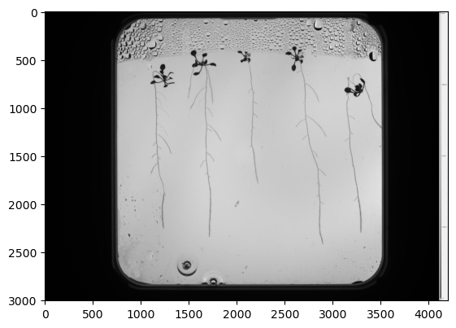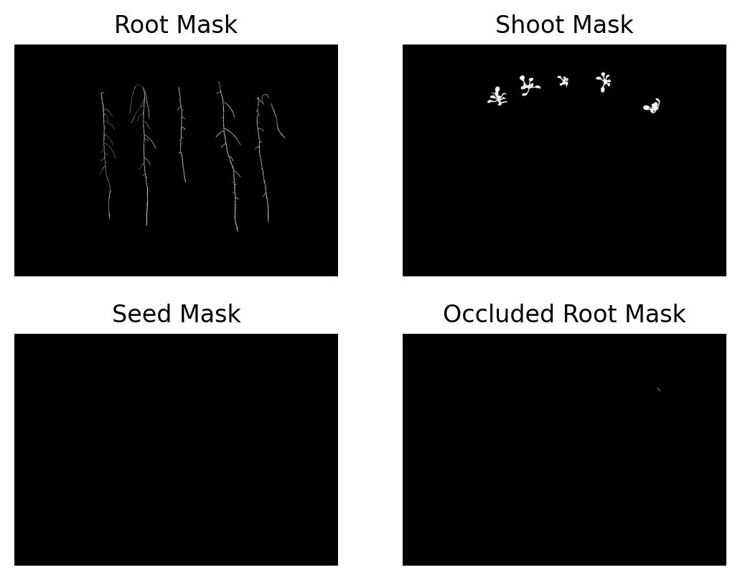

Figure 1 Original image Figure 2 Masks

Above is an example of one of the images that had to be segmented. For each image, 4 masks were segmented using Lab kit: Root mask, shoot mask, seed mask and occluded mask.   
The solution that I provided passed the client requirements, as I delivered 4 masks per image (as seen above), it had the correct naming convention, the image shape and mask shape match, it is a binary image, and my labels were of acceptable quality. The only constraint that I came up to was to figure out where the shoot ended and where the root started. I overcame this challenge by looking at where the lateral roots started to form and using that, I could predict where the shoot ended better.

**Task 2: ROI Extractionn:**   
Task 2 focused on Region of Interest (ROI) Extraction, involving the identification and isolation of Petri dishes from raw images in the dataset. We were required to write a Python code using traditional computer vision methods to crop the Petri dish from any raw image, assuming it is a square with its edges parallel to the image borders. The code had to be generalizable to all dataset images and must not rely on machine learning or deep learning models. Specific client requirements include ensuring the detected Petri dish edges are within around 15 pixels of the actual edges and producing a square-cropped image.

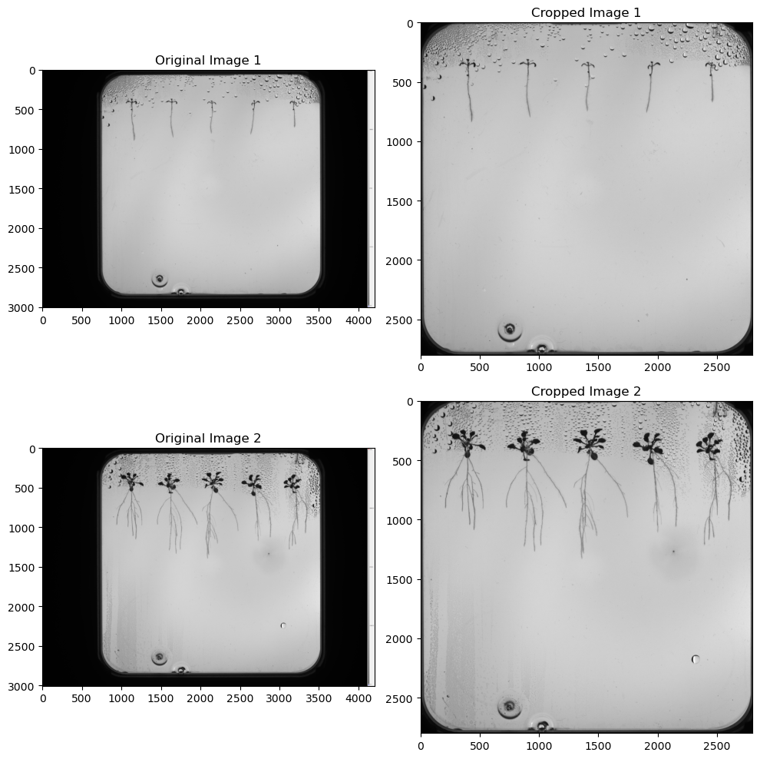

Figure 3 Original Image and Cropped Image

Above you can see an example of the result of the image before and after cropping it. This solution works well with other images as well, so it meets the client requirements. I did not run into any problems during this task as I first tried to do it by finding the coordinates of the 4 corners and then cropping the image, but this solution did not work with other images. So, I then tried with “connectedComponentsWithStats”, this solution worked better and worked with other images.

**Task 3: Instance Segmentation (Traditional CV):**Task 3 involved traditional computer vision-based instance segmentation for five plants in the dataset. The objective was to differentiate individual plants using only traditional CV methods, without utilizing ML/DL models. The code (task_3. ipynb) had to be generalizable and work on at least two specified images.

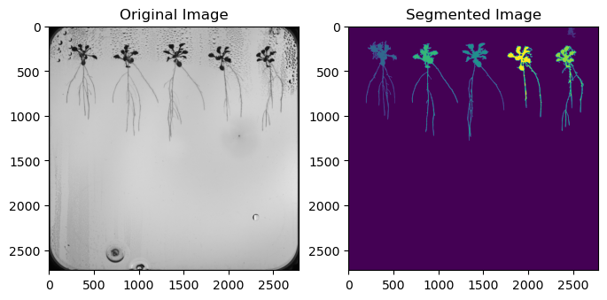

Figure 4 Original Image and Image after segmentation

Above you can see an example of the original image and the image after segmentation. My code for the segmentation passes the client requirements as it was generalizable and could work on the 2 specified images. Durin this task the most difficult part was to find a threshold that is high enough to show the roots but also clear the background. I overcame this obstacle by just playing around with the threshold until it worked. The solution clearly worked as you can see the original image, the segmentation shows the number of plants it recognized in the image in a different colour each.

**Task 4: Semantic Segmentation (Deep Learning)**In Task 4, the focus shifted to deep learning-based semantic segmentation using the annotated dataset from Task 1. The objective was to segment root, seed, shoot, and occluded root classes. Deliverables included task_4.ipynb with learning curves, example input images with resulting segmentation masks and IoU on the root test set higher than 0.5.  
So in task 4 we used the segmented masks from task 1 to predict the roots, shoot, seeds and occluded roots of a given image. Before doing this I needed to preprocess the images by cropping the images using the function defined in task 2, I then padded and patched the images. I then stored the images and masks in directories as seen in figure 5. Next I used a function that reads the images and its corresponding masks from a specified directory and scales them and then splits them into patches of the specified size. This function returns 2 numpy arrays containing the patches of the images and their corresponding masks. I used this function to generate my test, train and validation data.  
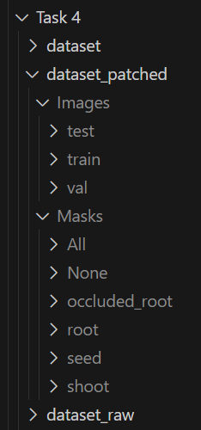 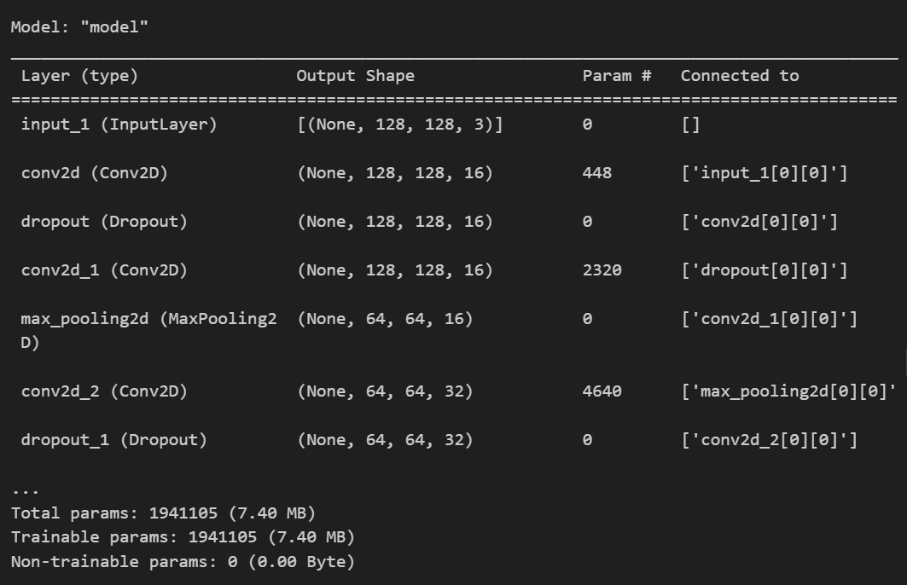

Figure 5 Directories Figure 6 Model Architecture

I then created a model (see figure 6) and trained the model using the training data and validated my model using the validation data. I repeated this process for the roots, shoot, seed and occluded roots.

|  |  |  |
| --- | --- | --- |
| Metric | Training | Validation |
| Loss | 0.0074 | 0.0133 |
| Accuracy | 0.9970 | 0.9946 |
| F1 Score | 0.7802 | 0.7579 |
| IOU | 0.1638 | 0.1794 (0.6469 after threshold) |

### Root Model:

### 

Figure 5 Root model metrics

After training my root_model my accuracy was 0.9970 and my 0.1794. The IOU was too low, so to fix this issue I thresholded my predictions of the root_model. This way when predicting the mask, it will predict the value of the roots between 0 or 1. This increased my IOU score to 0.6469, doing this also helped me pass the client requirements of having my root_model having an IOU higher than 0.5.

### Shoot Model:

|  |  |  |
| --- | --- | --- |
| Metric | Training | Validation |
| Loss | 0.0080 | 0.0087 |
| Accuracy | 0.9970 | 0.9968 |
| F1 Score | 0.4755 | 0.6394 |
| IOU | 0.0493 | 0.0728 |

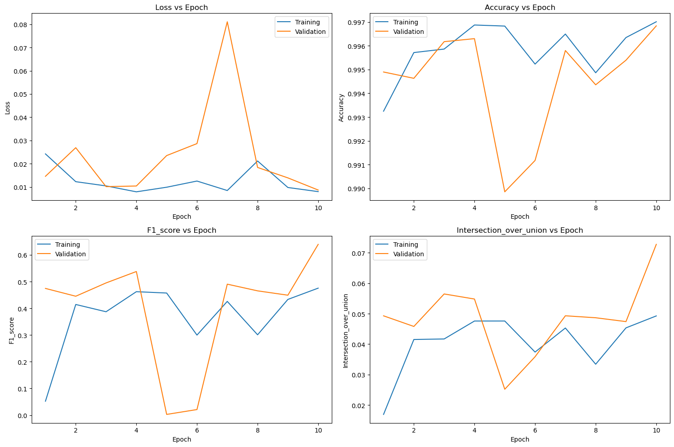

Figure 6 Shoot model metrics

Above you can see my metrics when training my shoot model. The IOU is low here, this is because I only trained the model for 10 epochs. A solution for this would be to train the model for more epochs and to use early stopping to find the optimal training solution.

### Seed Model:

|  |  |  |
| --- | --- | --- |
| Metric | Training | Validation |
| Loss | 3.3642e-04 | 4.3301e-04 |
| Accuracy | 0.9999 | 0.9999 |
| F1 Score | 0.1425 | 0.1499 |
| IOU | 0.0268 | 0.0246 |

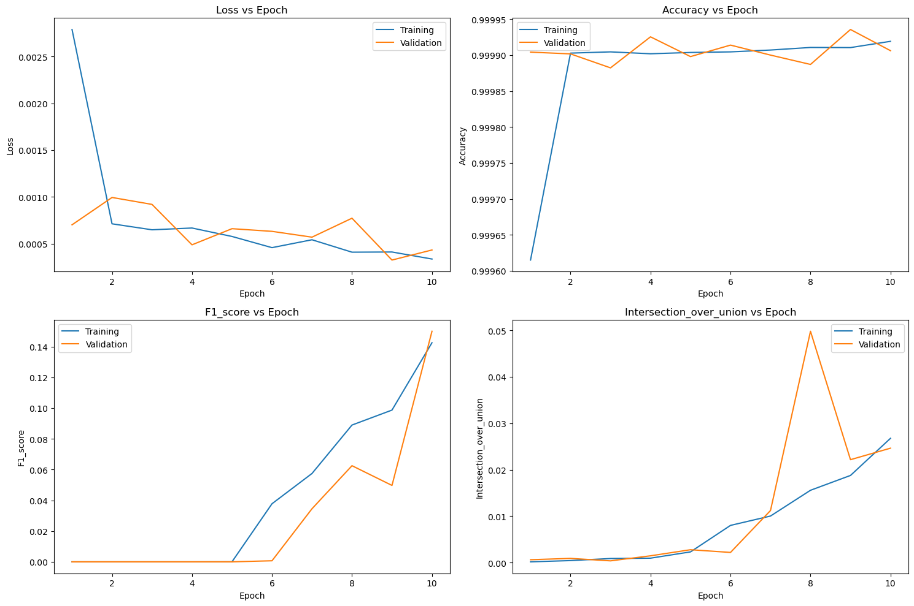

Figure 7 Seed model metrics

Above you can see my metrics when training my seed model. The IOU is low here, this is because there are not enough masks with seeds in them. A solution for this would be to make the training data more representative as right now the model is struggling to generalize unseen data. So, adding more diverse data in the training set would improve performance.

### Occluded Root Model:

|  |  |  |
| --- | --- | --- |
| Metric | Training | Validation |
| Loss | 4.1436e-04 | 0.0024 |
| Accuracy | 1.0000 | 0.9997 |
| F1 Score | 0.0000e+00 | 0.0000e+00 |
| IOU | 0.0217 | 0.0047 |

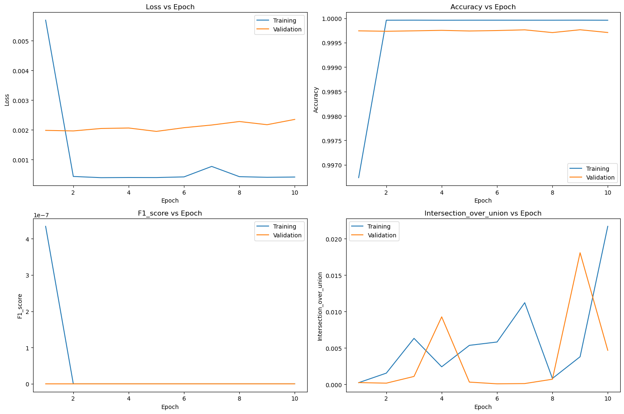

Figure 8 Occluded Root model metrics

Above you can see my metrics when training my root_model. The F1 is low here, this is because there are not enough masks with occluded roots in them. A solution for this would be to make the training data more representative as right now the model is struggling to generalize unseen data. So, adding more diverse data in the training set would improve performance.

**Task 5: Instance Segmentation (Post-Processing):**Task 5 required applying instance segmentation to the output of the Task 4 model. The client requirement was that the number of detected instances should match the number of plants in the image.

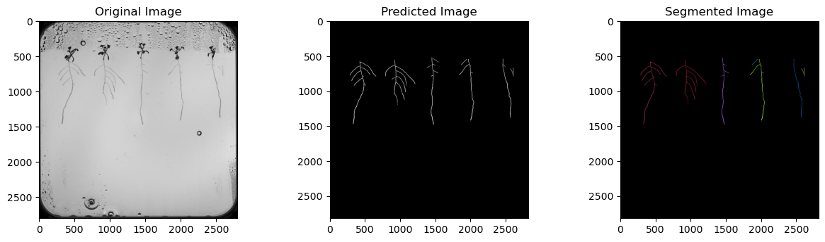

Figure 9 Original Image, Predicted Mask and Segmented mask

Above you can see the input image, the predicted mask of the image (using the root_model) and the segmented mask. The segmentation did not pass the client requirements as it is predicting there are 6 plants in the image when there are only 5. This is because the predicted mask is missing part of a root. A solution for this would be to use post-processing techniques like Non-Maximum Suppression (NMS) to fine-tune and filter out redundant bounding boxes to improve the predictions of the model.

**Task 6: Landmark Detection:**Task 6 focused on landmark detection for root tips, junctions, and lateral root tips. The client requirements were that the code (task_6.ipynb) must quantify errors for primary root landmarks and visualize predictions for lateral root tips. Specific requirements for mean absolute error (for root should be less than 100 pixels) and visualization are provided.

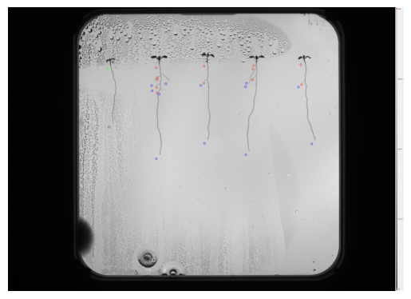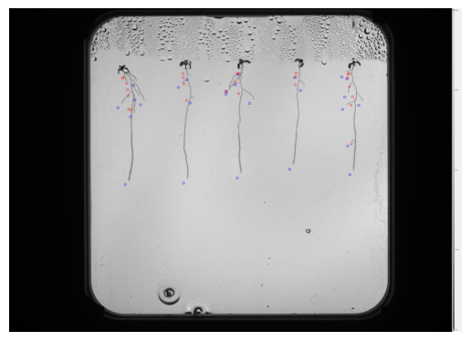

Figure 10 Predicted coordinates of plants 1 and 2

|  |  |
| --- | --- |
| MSE plant 1 | 1063.521374683085 pixels |
| MSE plant 2 | 1232.1449338299017 pixels |

Above you can see the results of the landmark detection. My results only passed half of the client requirements as I was able to visualize the primary root landmarks and the lateral root tips. I was however unable to pass requirements for the MSE error of the plants as it was lower than 100 pixels for both plants. A solution for this would be to improve the root_model that was used to predict the roots, by perhaps using NMS to fine-tune and filter out redundant bounding boxes to improve the predictions of the model.

**Task 7: Morphometric Analysis**Task 7 involved morphometric analysis to calculate primary root length and total lateral root length. The client requirements for this task were that the code (task_7.ipynb) must quantify sMAPE for primary and lateral root lengths, demonstrating performance on provided images. The sMAPE for the primary roots had to be less than 20% and the sMAPE of the total lengths of the lateral roots had to be less than 50%

|  |  |  |
| --- | --- | --- |
| Roots | Plant 1 | Plant 2 |
| Primary root sMAPE | 2.3582867062126183 | 5.433788065806645 |
| Lateral roots sMAPE | 145.0858368421873 | 89.62197208249411 |

Above you can see the sMAPE of the roots of the plant that were measured. My solution passed the client requirements for the primary root but not for the lateral roots. An alternative solution to fix this would be to improve the root_model that was used to predict the roots, by perhaps using NMS to fine-tune and filter out redundant bounding boxes to improve the predictions of the model.

**Task 8: Kaggle Competition**Task 8 integrated skills from Tasks 1 to 7, requiring the development of a comprehensive computer vision pipeline. The task involved predicting primary root lengths of 11 plants for a Kaggle competition, assessing the solution's performance on a private leaderboard. Deliverables include well-documented code (task_8.ipynb) and a technical report summarizing the pipeline and results. The sMAPE score needs to be higher than 50%.

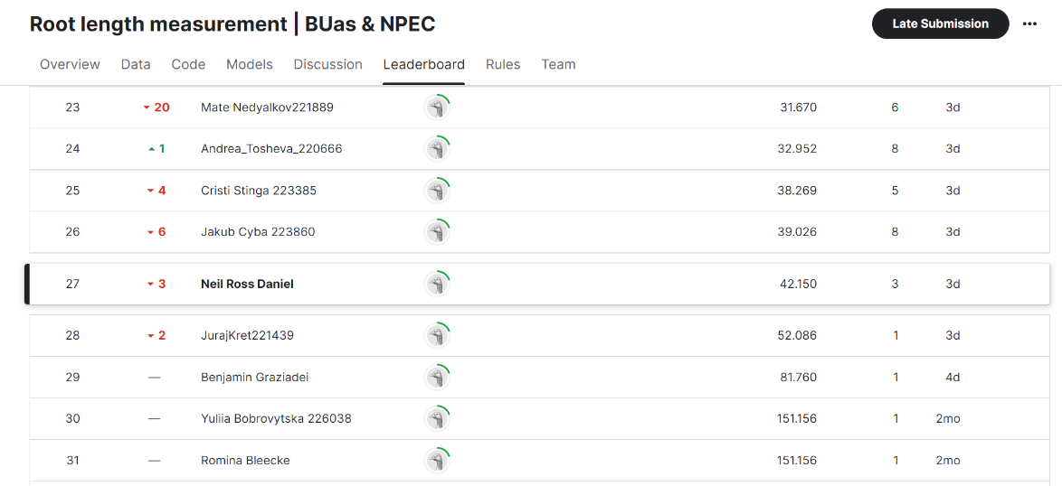

Figure 11 Kaggle Competition standings

Above you can see my private leaderboard score of the predictions of the length of the primary roots. I got a score of 42.150 which passes the client requirement of having a sMAPE score higher than 50%. The score could be improved by improving the root_model that was used to make the predictions.

**Task 9 Kaggle Simulation environment**

For task 9 we needed to set up a simulation environment for the Opentron OT-2, move the pipette to each corner of the working envelope, record coordinates, and provide code for sending commands and receiving observations.

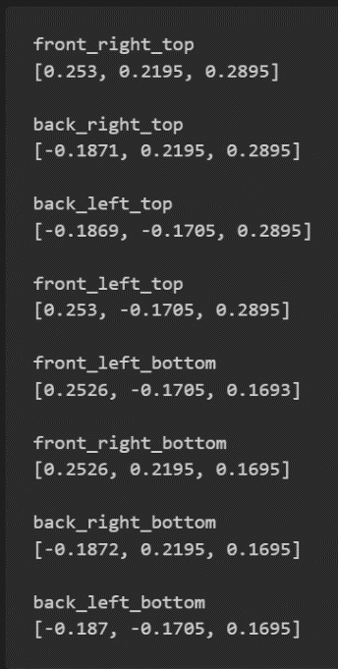 In Figure 12 you can see the coordinates of the corners of the working envelope. The solution meets the task requirements by establishing a simulation environment and recording pipette coordinates. Client requirements are satisfied as the robot's response to commands and observations is demonstrated. There is a possibility that there are some design constraints; there might be hardware limitations or inaccuracies in simulation compared to the physical robot. I did run into some challenges ensuring accurate simulation. I solved this challenge by fine-tuning simulation parameters.

Figure 12 Coordinates of the corners of the simulation

**Task 10: Creating a Gym environment  
**For Task 10 we needed to create a Gym wrapper for the pyBullet simulation to make it compatible with Stable Baselines 3, defining properties and methods.

Figure 13 shows a gif of the testing of my OT2_gym_wrapper. The solution meets the task requirements by creating a Gym wrapper with necessary properties and methods and the environment is prepared for reinforcement learning with Stable Baselines 3. Challenges faced during this task was understanding *Figure 13 Gif of OT2 environment testing* Gym's requirements, I overcame this challenge by looking through the Gym documentation.

**Task 11: Reinforcement Learning**

For task 11 we had to train a reinforcement learning algorithm using Stable Baselines 3 to control the Opentrons OT-2. Perform a hyperparameter search and track experiments using Weights and Biases.

Client requirements were to give a well-documented RL training and testing code for and a code for the RL testing. The best performing hyperparameters had to be summarized in the report. Weights of the best performing model for each student and the group. GIF of the robot moving to given coordinates.

|  |  |
| --- | --- |
| Model 1 Hyperparameters | |
| Learning Rate | 0.0001 |
| Batch Size | 64 |
| N_steps | 2048 |
| N_epochs | 10 |

The reinforcement learning Model 1 was created using proximal Policy Optimization (PPO).  
Bellow you can see the reward function used. $$reward={\left|\left|pipette_{pos}-self.goal_{pos}\right|\right|}^{2}$$

* pipette_pos: represents the position of the pipette.
* self.goal_pos: represents the goal position.
* ∥ ⋅ ∥ 2 ∥⋅∥ 2: ​ denotes the Euclidean norm.

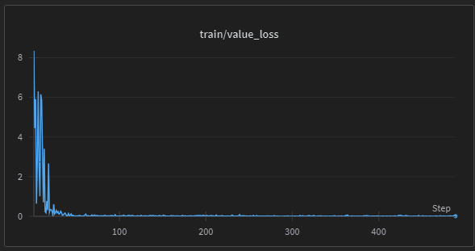 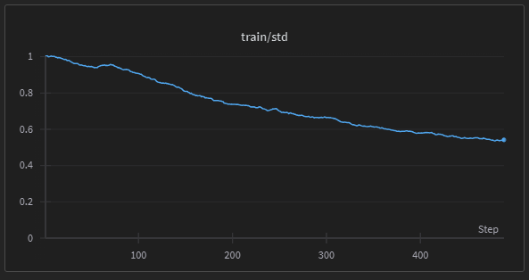

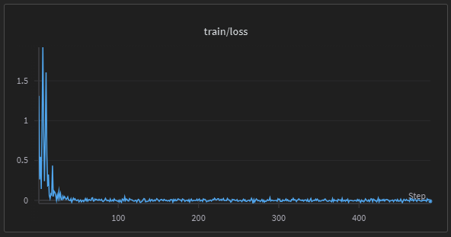 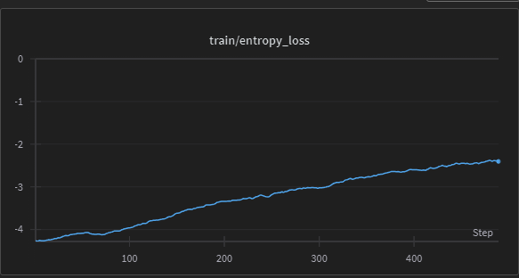

Figure 14 Model 1 and plots

The model’s value loss experienced a significant loss at the initial training steps but stabilized and gradually improved as the steps increased. This is a good sign, indicating that the model is learning and improving over time.

The model’s training standard deviation shows a decreasing trend oversteps. It starts at a value close to 1 and decreases steadily as the number of steps increases, leveling off near a value of 0.45. This is a good sign, as it means that my model is becoming more stable and consistent over time.

 Initially, the loss is high, indicating that the model’s predictions are far from accurate. However, as training progresses ,the loss rapidly decreases and then stabilizes, indicating that the model is improving and becoming more accurate. The loss value fluctuates slightly around a low value close to zero for the remainder of training.

The model’s training entropy loss shows as the number of steps increases, the entropy loss decreases, indicating that the model is learning and improving its performance.

The model undergoes positive training progress as indicated by several key metrics. The value loss initially experiences a significant decrease, stabilizing over time, suggesting that the model is learning and improving. The training standard deviation shows a consistent decline, signifying increased stability and consistency in the model's predictions. Despite an initially high loss, it rapidly decreases during training, indicating improved accuracy. The loss then remains low, fluctuating slightly around zero, showcasing the model's sustained accuracy. Additionally, the training entropy loss decreases with an increasing number of steps, highlighting the model's learning and performance improvement. Overall, these trends reflect the model's positive development and enhanced capabilities over the training duration.

|  |  |
| --- | --- |
| Model 2 Hyperparameters | |
| Learning Rate | 0.001 |
| Batch Size | 65 |
| N_steps | 2050 |
| N_epochs | 100 |

The reinforcement learning Model 2 was created using the same reward function and model type, only the Hyperparameters were changed.

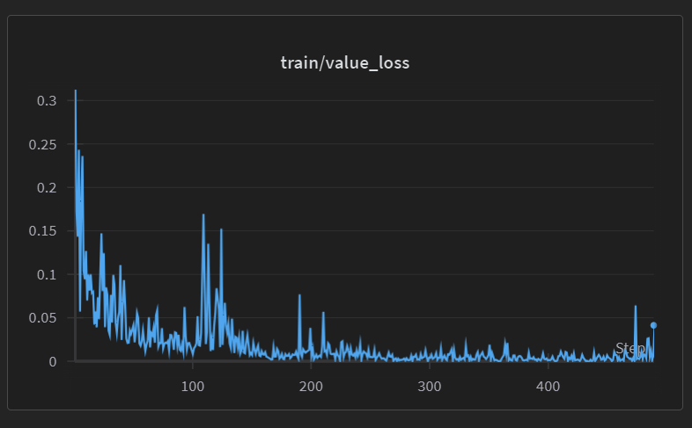 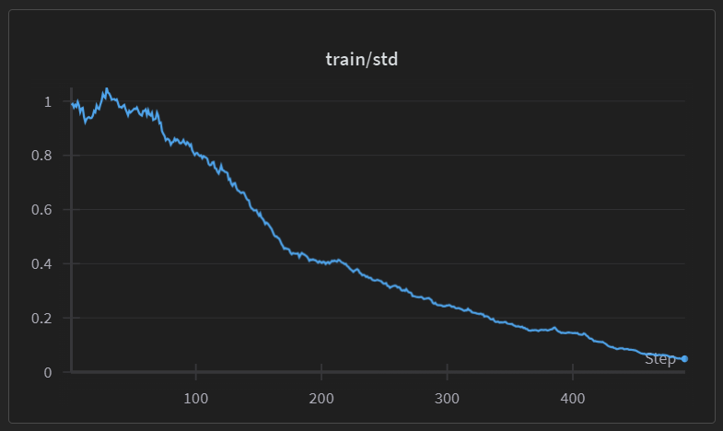

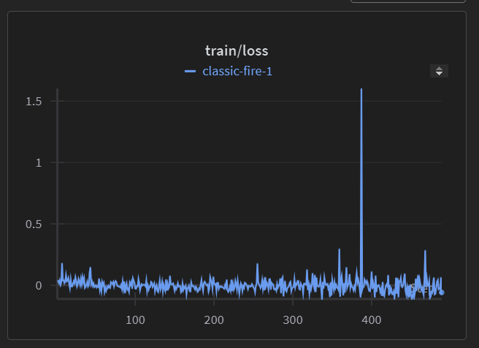 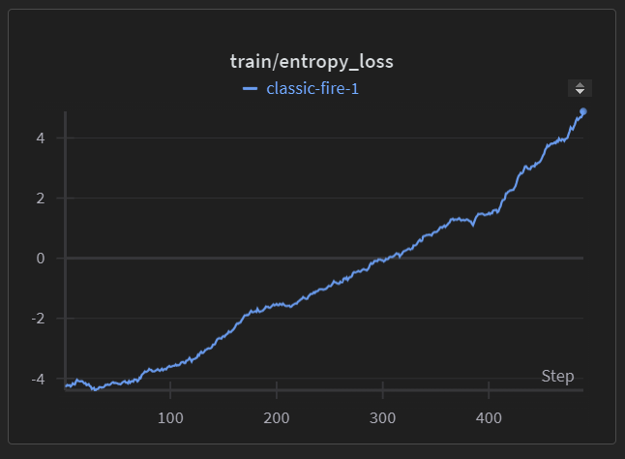

Figure 15 Model 2 and plots

The training value loss graph indicates positive aspects of the model's learning and adaptation. The decreasing trend in loss over epochs suggests effective learning, with an initial high loss that significantly reduces, indicating improvements in predictions. Spikes in loss values at various points indicate the model's ability to adapt to training data complexities, though further investigation is required, especially around epochs 50, 150, and 400. The model shows a sensible learning duration, with improvements observed over 400 epochs. The "STOP" annotation near epoch 400 reflects an awareness of potential issues at critical points, requiring detailed analysis. Ensuring consistency in performance and addressing concerns identified during spikes is crucial for reliable predictions.

The training standard deviation graph highlights positive aspects of the model's stability. The steady decrease in standard deviation indicates that the model is becoming more stable over time, with a convergence towards 0.2 at 400 steps. However, an initial high standard deviation suggests some variability or uncertainty in the early training stages, warranting investigation. Consistency in the decreasing trend is essential, and spikes in later steps should be thoroughly analyzed. Overall, the decreasing standard deviation indicates improved model consistency, contributing to reliable predictions.

The model’s training loss is relatively stable throughout the training process, apart from a significant spike around epoch 400. This could indicate an anomaly or issue that occurred at that specific point during the training process.

This model’s **entropy loss** increases as the number of steps increases. It starts from a negative value and rises sharply after approximately 200 steps. This could indicate that the model is **overfitting** to the training data, meaning that it is becoming too specialized to the training data and may not generalize well to new data.

To summarize, the model demonstrates promise with a decreasing trend in both training value loss and standard deviation. However, spikes in value loss and the annotated point near 400 epochs require detailed investigation. Maintaining consistency in improvement and addressing concerns identified during spikes is essential for ensuring the model's reliability. Thorough analysis and potential adjustments to the training process or model architecture may enhance overall performance.

Comparison:

Both models show positive signs of learning and improvement, with decreasing value loss and standard deviation. Model 1 appeared to have more consistent and stable performance throughout training, with a low and steady value loss and standard deviation. Model 2 exhibited spikes in value loss and standard deviation, particularly around epoch 400, indicating potential issues that need investigation. Model 1's entropy loss decreases, while Model 2's entropy loss increases, suggesting Model 1 might generalize better to new data.

Conclusion: Model 1 seems to have a more stable and consistent training process, which may indicate better generalization to new data.

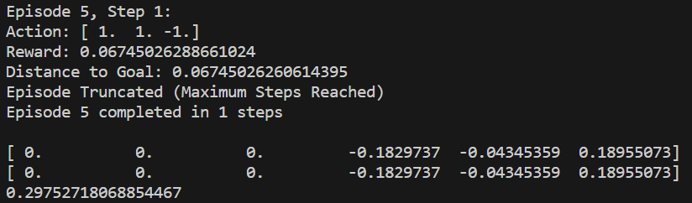

Figure 16 testing of model 1

|  |  |  |  |  |  |
| --- | --- | --- | --- | --- | --- |
| Team | type model | learning rate | batch size | n_steps | n_epochs |
| Bogdan | PPO | 0.0001 | 64 | 2048 | 10 |
| Christian | PPO | 0.0006 | 64 | 4096 | 128 |
| Andrea | DDPG | 0.001 | 100 | -1 | 100 |
| Borislav | PPO | 0.0005 | 128 | 4096 | 32 |
| Neil | PPO | 0.0001 | 64 | 2048 | 10 |

Above you can see the hyperparameters of the best performing models of our team. As shown by the graphs in figure 15 and figure 14, my model works well as the solution meets the task requirements by training RL algorithms, performing hyperparameter searches, and documenting results.

Client requirements are met by achieving optimal hyperparameters and training models.

The only challenges faced during the task were computational limitations, this was fixed using the ClearML Job Queue.

**Task 12: Creating a Controller**

Develop a PID controller for the Opentrons OT-2 with three controllers for each axis. Tune the PID controller to find the best performing gains. Results: Well-documented PID controller code. Testing process documentation. Best performing PID gains summarized in the report. GIF of the robot moving to given coordinates using the PID controller. Link to the technical report documenting PID controller

parameters and results.

Above you can see the gif of the controller moving in the gym environment. The solution meets the task requirements by creating a PID controller, tuning gains, and documenting results. Client requirements are satisfied as the PID controller successfully moves the robot to desired positions. Figure gif of controller

The challenge in this task was fine-tuning PID gains, this was addressed through iterative testing and adjustment.

**Task 13: Integrating the Computer Vision Pipeline**

For task 13 we needed to integrate the computer vision pipeline with the RL and PID controllers, modifying them to accept the output of the computer vision pipeline as input. Inoculate root tips are present in multiple specimen plates. I have not completed this task.

**Task 14: Controller Performance Benchmarking**

For task 14 we needed to benchmark the performance of RL and PID controllers, quantifying metrics such as speed and accuracy. Determine the best way to measure and compare the performance of the two controllers. I have not completed this task

# Overall Results

## Integration (See Figure 15 for the full pipeline)

In task 1, I successfully annotated images with pixel-level segmentation masks for roots, shoots, seeds, and occluded roots. This provided essential labeled data for subsequent tasks, forming the foundation for training deep learning models in Task 4. (see Figure 15 for more information.)

In task 2, I developed a generalizable Python code using traditional computer vision methods to crop Petri dishes accurately. This Ensured that subsequent tasks (like Instance Segmentation in Task 3) work on relevant regions of interest, improving efficiency. (see Figure 15 for more information.)

In task 3, I achieved segmentation of plants using traditional computer vision methods on specified images. This provided a baseline for evaluating the performance of deep learning-based segmentation in Task 4. (see Figure 15 for more information.)

In task 4 I successfully trained deep learning models for root, shoot, seed, and occluded root segmentation. This helped in predicting the roots masks in the rest of the tasks. (see Figure 15 for more information.)

In task 5, I applied instance segmentation to Task 4's outputs, although there were issues in predicting the correct number of instances. This helped identify the number of plants in the image, which was used further in the following tasks. (see Figure 15 for more information.)

In task 6, I successfully detected primary root landmarks and visualized lateral root tips but fell short in meeting MSE requirements. This provided insights into the precision of predictions, influencing subsequent morphometric analysis in Task 7. (see Figure 15 for more information.)

In task 7, I successfully conducted morphometric analysis on primary and lateral roots, meeting primary root sMAPE requirements but falling short in lateral roots. This Integrated predictions from deep learning models and landmark detection into quantitative metrics. (see Figure 15 for more information.)

In task 8, I achieved a competitive score in predicting primary root lengths in the Kaggle competition.

This combined skills from all previous tasks, emphasizing the practical application of the pipeline in a real-world scenario. (see Figure 15 for more information.)

In task 9, I successfully set up a simulation environment for the Opentron OT-2. This enabled testing and development of controllers in a controlled environment before deployment on a physical robot. (see Figure 15 for more information.)

In task 10, I created a Gym wrapper for pyBullet simulation, facilitating compatibility with reinforcement learning algorithms. This prepared the simulation environment for integration with reinforcement learning algorithms in Task 11. (see Figure 15 for more information.)

In task 11, we trained a reinforcement learning algorithm for Opentron OT-2 control, achieving optimal hyperparameters. This successfully integrated reinforcement learning into the broader pipeline, bridging the gap between perception (computer vision) and action (robotic control). (see Figure 15 for more information.)

In task 12, I developed and tuned a PID controller for Opentron OT-2 with documented gains.

This provided an alternative control mechanism, allowing for benchmarking against reinforcement learning. (see Figure 15 for more information.)

In task 13, I would have integrated the computer vision pipeline with the RL and PID controllers. (see Figure 15 for more information.)

In task 14, I would have benchmarked the performance of RL and PID controllers. (see Figure 15 for more information.)

## Challenges Faced in Integration and Solutions:

In Task 9, a big challenge was encountered in ensuring accurate simulation, which was effectively addressed by fine-tuning simulation parameters to align with the physical robot. In Task 11, computational limitations posed a hurdle, but a solution was implemented through the utilization of the ClearML Job Queue. Moving on to Tasks 13 and 14, the focus shifted to enhancing the performance of the pipeline. However, the solutions for these tasks are currently pending, as they require careful integration and benchmarking to optimize the overall system performance

The pipeline I have developed demonstrates a robust integration of computer vision, machine learning, and robotics. Challenges that emerged during the development process were effectively addressed through thoughtful solutions, showcasing the adaptability and problem-solving capabilities of the system. The iterative nature of the approach employed in the development allows for continuous improvement, ensuring that the pipeline evolves and stays resilient. Furthermore, the presence of pending tasks in the pipeline indicates a forward-looking strategy, as these tasks are intended to refine and optimize the system further, aligning with a commitment to ongoing enhancement and advancement.

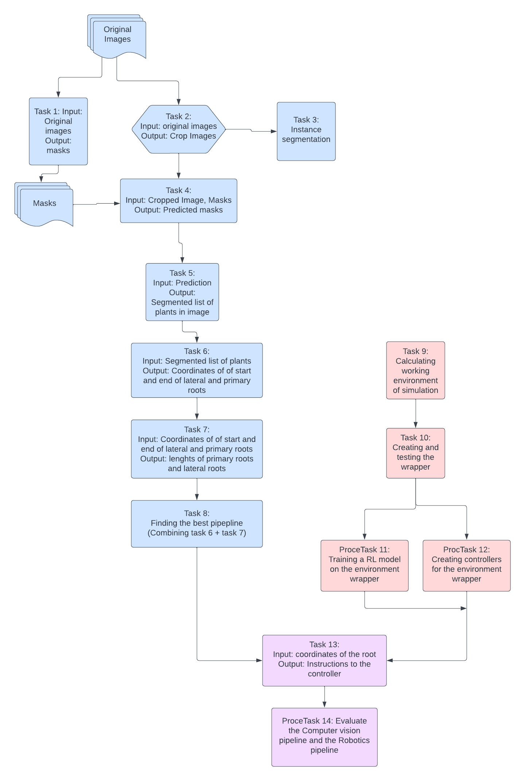

Figure 18 Flowchart of pipelines (Blue= Computer Vision Pipeline, Red= Robotics Pipeline, Purple= integration of both pipelines)

# Conclusion

The development of a comprehensive computer vision and robotics pipeline highlights the ability to address diverse tasks, ranging from image annotation to reinforcement learning and robotic control. Challenges encountered in instance segmentation, landmark detection, and morphometric analysis underscore the complexity of integrating various components into a cohesive system. The practical application of the pipeline in a Kaggle competition and the establishment of a simulation environment for Opentron OT-2 showcase the practicality and versatility of the developed skills. Identification of areas for improvement in instance segmentation, morphometric analysis, and controller performance benchmarking emphasizes the importance of an iterative approach for refining the pipeline.

The project's breadth, encompassing image annotation, traditional computer vision, deep learning, reinforcement learning, and robotics, has contributed to a holistic skill set. Overcoming challenges in each task has honed adaptive problem-solving skills, fostering a deeper understanding of the intricacies involved in computer vision and robotics. The necessity for interdisciplinary collaboration, integrating computer vision with robotics, underscores the importance of such approaches in addressing complex problems. The transition from theory to practice in the Kaggle competition and the creation of a simulation environment has provided hands-on experience, solidifying theoretical knowledge. The iterative nature of the project, with identified areas for improvement, underscores the importance of continuous learning and adaptation in the dynamic fields of computer vision and robotics.

Further refinement of deep learning models, possibly incorporating advanced techniques like Non-Maximum Suppression for improved instance segmentation. Enhancing model generalization through increased diversity in the training dataset, especially for classes with limited representation. Continued refinement and optimization of controllers, incorporating lessons learned from benchmarking and PID tuning. Transitioning the pipeline from simulations to real-world scenarios, addressing any potential discrepancies between simulated and physical environments.

In conclusion, the project has been instrumental in developing a diverse skill set, fostering problem-solving abilities, and emphasizing the practical application of theoretical knowledge in the dynamic fields of computer vision and robotics. The journey, though challenging, has been immensely rewarding, laying the groundwork for continuous learning and growth in future endeavors.

# References

Alexei A. Efros, A. T. (2011). *Unbiased Look at Dataset Bias.*

Noyan, M. A. (2022). *Uncovering bias in the PlantVillage dataset.* New York: Cornell University.